CURRICULUM VITAE
of

Faculty of Medicine

Benha University

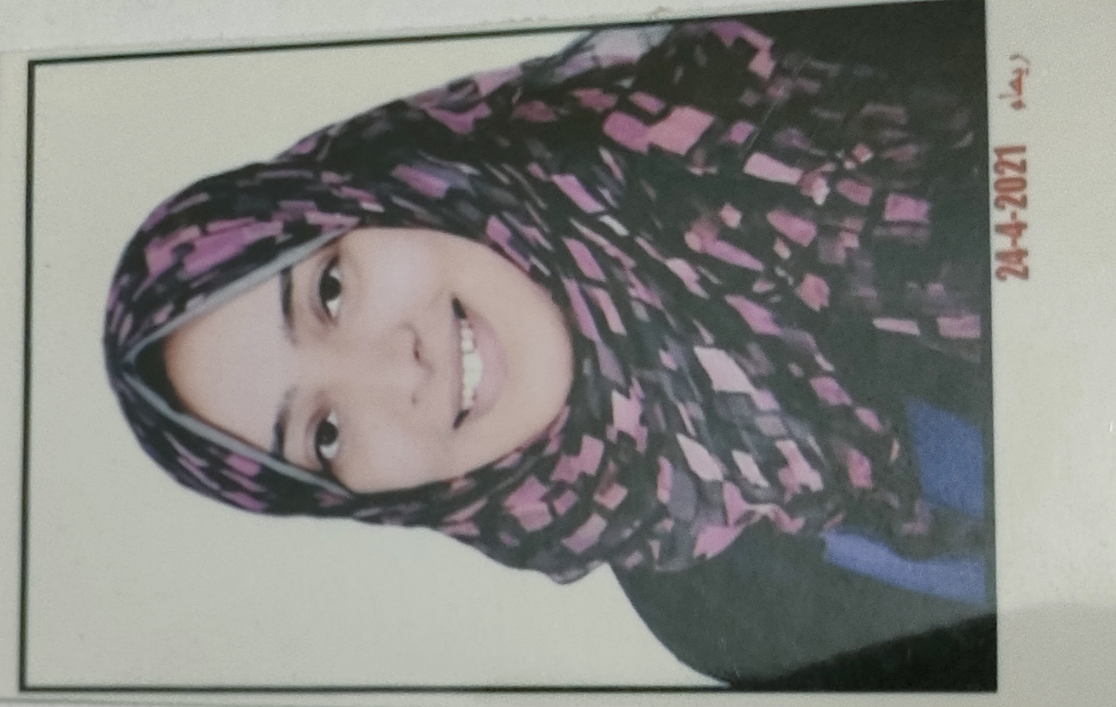

Personal photo

Personal Data
Name (Arabic) | شيرين اشرف عبدالعزيز غريب على السويدى
Name (English) | Shereen Ashraf Abdelaziz Gharib Ali Elsweedy
Department | Forensic and clinical toxicology department
College | Faculty of medicine benha university
Academic degree | Teaching assistant
Mobile | 01067438375
Home phone
work phone
Email (university) | sherysweedy@gmail.com
Alternative E mail | Shereeenelsweedy2019@gmail.com
Web site

Education
Institution | Degrees obtained | Year
Benha University | bachelor Of medicine and general surgery | 2018
Benha University | Master degree of forensic medicine and clinical toxicology | 2024
Benha University

General specialty | medicine and general surgery
Specific specialty | Forensic medicine and clinical toxicology

Language
Language | Reading | Speaking | Writing
Arabic | Excellent | Excellent | Excellent
English | Excellent | Excellent | Excellent

Membership of Professional Bodies (List)

Interesting Areas of Research
- Forensic medicine
- Anthropology studies
- Clinical toxicology
- Analytical toxicology
- Environmental toxicology
- Postmortem toxicology
- Toxicological pathology

MSc Supervision
Title | Year completed / in  Progress

Title | Year completed / in progress

Positions
Date From - to |  | Organization | Country | Position | Role
1 | 2020 to2024 | Faculty of medicine benha university | Egypt | Demonstrator | Teaching and research
2 | 2024 till now | Faculty of medicine benha university | Egypt | Teaching assistant | Teaching and research
3
4
5

Attended Workshops, Symposiums, and Conference
Name of Workshops, Symposiums, and Conferences | Year
4th annual benha forensic medicine and clinical toxicology conference  Fingerprint identification workshop  Detection of forgery and Counterfeiting documents workshop  Workshop on violence against women in collaboration with the national council for women | 2024

- Training and Clinical Experience:
a- resident at benha University hospital (benha poisoning control unit)
b- teaching at forensic medicine and clinical toxicology department, benha faculty of medicine

- Skills:
    - Clinical reasoning and diagnostic skills
    - computer skills (word , PowerPoint ,excel )
    - presentation skills
    - clinical research skills
    - problem solving
    - communication skills
    - time management

b.

- List of publications:

  - Potential protective effects of atorvastatin on lead induced neurotoxicity

